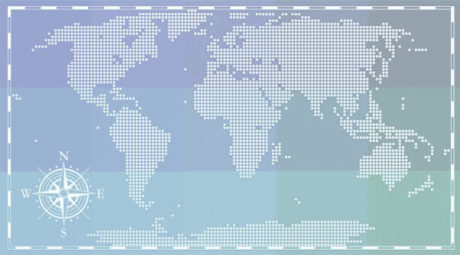

**THE CENTRAL PACIFIC DISTRICT MISSIONS**

**OUR CPD INTERNATIONAL WORKERS (IW) HIGHLIGHTS**

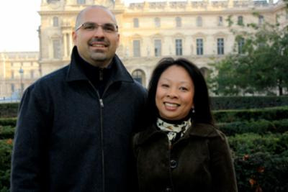**](https://www.youtube.com/watch?v=9j5n4Meab4Q&feature=youtu.be)**

 **THE CHAPMAN FAMILY** **JASON HO & ANDI KUO THE BOWER FAMILY**

We are excited to welcome in July 2021 one of our CPD IW serving in Paris, France. This is their first Home Assignment, and they are thrilled to share with our churches God’s wonders. For a brief bio of them**,** [**click here.**](https://www.dropbox.com/s/w0mxn2x4voaog4g/The%20Bower%20Family.pdf?dl=0)

The Chapman family have raised their monthly support!! Thank you to all those who are part of their journey. Read their testimony of this **“**[**BIG NEWS”**](https://www.dropbox.com/s/w3iupwgglzxq5cy/The%20Chapman%20Family.pdf?dl=0)

and watch the video above .

Jason and Andi have been in the Twain Field since the first week of January 2021. I am in awe of God’s power before taking them to the field. Read for yourself [**their testimony**](https://www.dropbox.com/s/bl7le9l4dj5en6f/Jason%20and%20Andi%20Newsletter%202021.01%20English%20%281%29.pdf?dl=0)as you see the Lord’s might hand upon them.

**MISSIONS EMPHASIS EVENT**

We have the new list of IWs available to speak in your missions conference event 2021! email [karla@cpdistrict.org](mailto:karla@cpdistrict.org)



**CPD UPDATES**

**NATIONAL OFFICE ALLIANCE MISSIONS UPDATES**

**NEW GREAT COMMISION Funding Model:**

***](https://www.dropbox.com/s/h7lk0ij366bom5b/District_Conference_Short.mp4?dl=0) **CONVERGE 2021**

**NOTE:** Get to know our CPD International Workers . We have a great team around the word. Call me or email me to know more about them! *(security guidelines for international workers (IWs)serving in creative access countries must be followed).*

](https://www.bigmarker.com/cmalliance/Converge-2021-Q-A-with-Tim-Crouch?bmid=4aeca831129f)

**BAYAMO SEMINARY PROJECT UPDATE**

We want to thank all the churches that have been supporting this project. The district remains faithful in supporting our leaders and pastors in this region. For more information about this project that we feel blessed to be a part of, contact Karla Tovar.

In this short video, Tim Crouch is sharing important information regarding the new system to support our district IWs.

Converge 2021: Turning COVID-Era Obstacles into Opportunities. [WATCH THE VIDEO SESSIONS.](http://www.bigmarker.com/series/converge-2021/series_summit)

The recording for Converge 2021: Q&A with Tim Crouch is now available to watch.