Central Pacific District
First Connections Evaluation Form

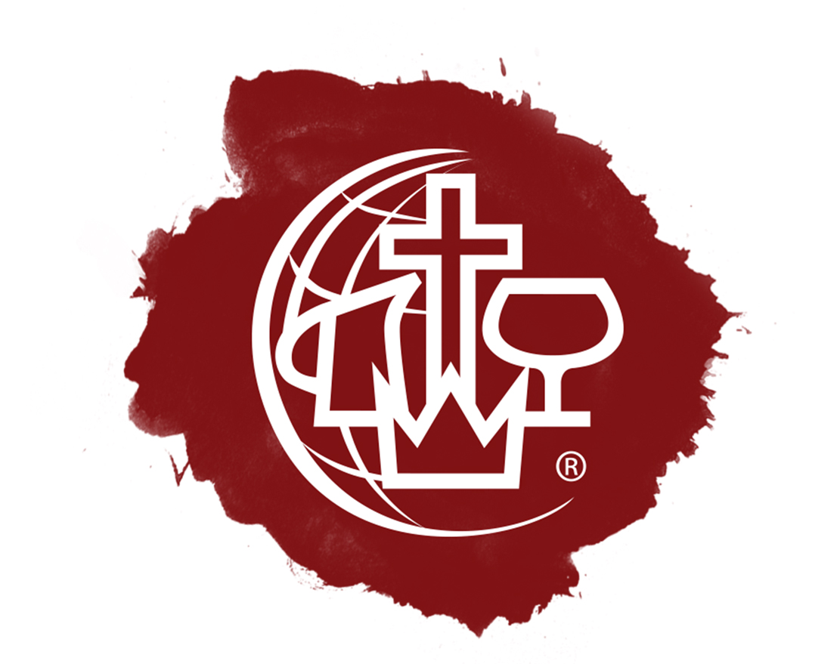
(Form is available electronically at CPD website)
Name of Emerging Leader:

Name of Interviewer:

Date of Interview:

Type of Interview:
Phone
Video Conferencing
Face-to-Face

General well-being (holistic):

Sense of call, conversion story, character:

Recommended Next Step:
Full Application (C&MA Website)
Sustain Previous Ordination Application
Divorce Appeal

Assessments
Formal Bible Education
Polity Course

Redirect
Unsure

Recommended Assessments:
IDAK
SDI
DISC
APEST
Church Planter Assessment
Other:

Is there a particular Mentor you would recommend:
Date to begin mentoring:

Information given to Emerging Leader:
Candidate Guidelines for The C&MA Accreditation Interview/Application Instructions
Quick Guide to Polity
Quick Guide to MSP / LEAD / RTI
Pathway Sheet

