OUTREACH TEMPERATURE CARD
Name: Date:
My Current Temperature:
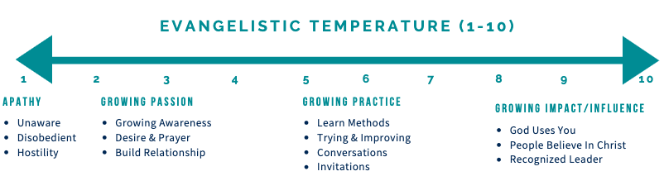
Recent Progress in Relationships or Spiritual Conversations:
Unchurched People:  - Friends  - Relatives  - Acquaintances  - Neighbors  - Colleagues  - Enemies  - Strangers/Strayed | Discern TIPS Next Step  1 -Trust  2- Interests  3- Pain points  4- Spiritual truth | BLESS missional practices I will pursue to build the relationship and to transition to the next stage of the TIPS for Conversations:  - Begin with Prayer  - Listen: ASK QUESTIONS to help the transition  - Eat: Connecting in social situations  - Serve Them and Ask for Their Help  - Share your Story and the Good News of Jesus: Invite Response | Date:

