**Introducing our Guest Speaker:**

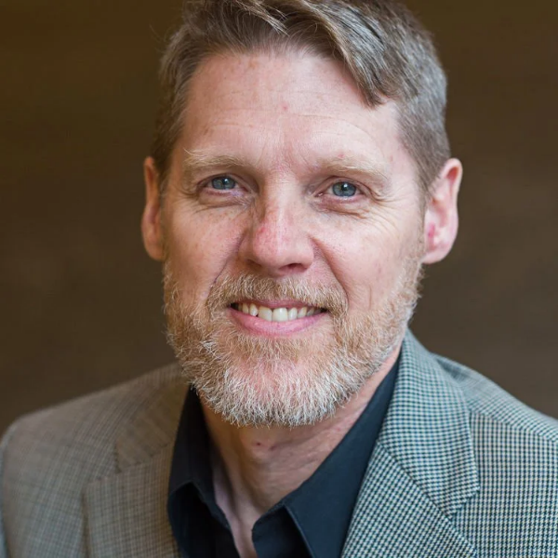

**Dr. Rob Reimer**

Dr. Rob Reimer’s passion is to see the Kingdom of God advance through spiritual renewal. Rob began Renewal International to assist pastors, leaders, and churches globally to equip the people of God to live in freedom in Christ, and to walk in the fullness and power of the Holy Spirit.

Passionate about Jesus, personally transparent, and saturated in the Word, his books including Soul Care, River Dwellers, Spiritual Authority, Deep Faith, Pathways to the King, The Soul Care Leader, Calm in the Storm and The Tenderness of Jesus incorporate lessons God taught him over the years through life, marriage, and ministry. During conferences, Rob not only teaches these lessons, but provides activities for participants to begin working them into their lives. These transformative experiences challenge people to walk in the light with God and others and help people to practice hearing from God and accessing His power for ministry. Without Jesus, we have nothing to offer!

In addition to his work with Renewal International, Dr. Reimer has served as Professor of Pastoral Theology at Alliance University in NY, NY, and as the founding and lead pastor of a church in New England. Explore more of Rob's resources, view his itinerary, or invite him to speak at: [Renewal International](https://renewalinternational.org/)