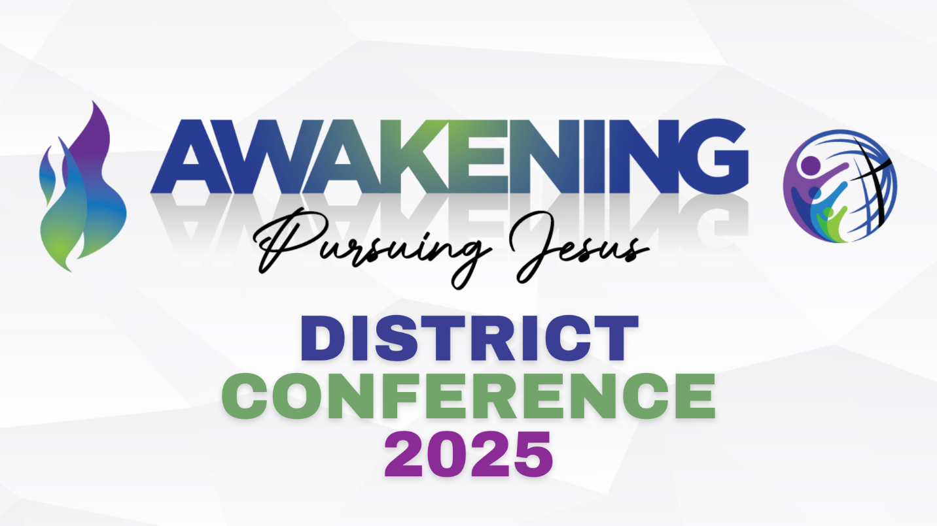
Pre-Conference Schedule
Tuesday, October 7th
- 9:00am – 2:30pm:

  - Prayer/Worship Time
    - Come join us in prayer and worship! You are welcome to join us for as little or as much of this time as you are available.
  - Ordinand Inservice Workshop
    - This seminar is from 9am until 2:30pm. This seminar is led by Shanon Lee and Bruce Guckelberg, and will be covering Completing Christs’ Mission.

- 9:00am – 12:00pm OR 12:30pm – 2:30pm:

  - How to Multiply Leaders in Your Local Church
    - This seminar is led by Rick Mann and is offered twice during the Pre-Conference Day. Please select only ONE time slot for the workshop.

- 10:00am – 2:30pm:

  - Deliverance Training
    - This seminar will unpack a basic theology and process to rain leaders about how to help people find freedom from demonic oppression. Rob Douglas will be leading this seminar.

- 12:30pm – 2:30pm:

  - Youth Ministry Workshop
    - This workshop is led by Alex Krum and will provide resources and discussion about youth ministry. This workshop is for people involved in youth ministry as lay people, solo pastors, and/or youth pastors.

- 3:00-5:00pm – Registration

- 3:00 – 5:00pm – Rob Reimer Workshop

  - Rob Reimer is our Guest Speaker for District Conference this year. Don’t miss out on what he has for us!

- DINNER: 5:00-6:30pm
  - Come join us for a time of fellowship and good food! There will be food trucks, music and lots of fun!

- 7:00 – 8:30pm – Official start of District Conference
  - Evening Worship Service

