ARISE · 2026 CENTRAL PACIFIC DISTRICT CONFERENCE
Plenary Speakers
October 5–8, 2026 · Chico Neighborhood Church
The voices from the platform. Seminar presenters are listed separately in the Seminar Tracks handout. Tuesday and Wednesday evening services are open to the public — invite your congregation.
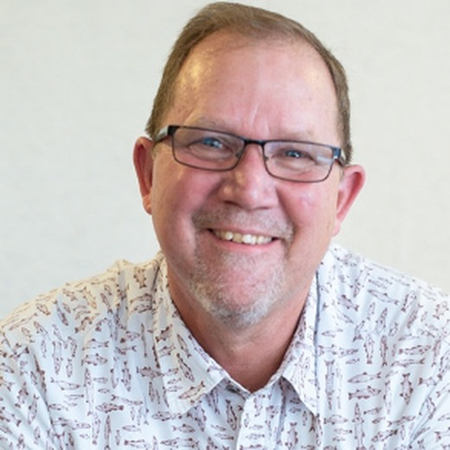 | Dr. Rob Douglas  District Superintendent, Central Pacific District  · Tuesday, October 6 — Opening Service, 9:00 a.m.  · Tuesday, October 6 — Hearing and Knowing the Voice of God, with Stacy, Session 2, 1:00 p.m.  · Tuesday, October 6 — Markers of the Soul, with Stacy, Session 3, 2:30 p.m.  · Wednesday, October 7 — Report of the District Superintendent, Business Session II, 2:05 p.m.  · Thursday, October 8 — Worship, Communion, and Healing, 9:00 a.m.  ABOUT  Dr. Rob Douglas was born in Southeast Asia and spent 14 of his first 18 years there as the son of missionary parents. Across more than 30 years of ministry he has served the C&MA in district and denominational leadership, pastoring, and international missions, and now serves as District Superintendent of the Central Pacific District.  Stacy is a pastor's kid who grew up in Michigan and Florida, worked as a nurse before serving overseas in Thailand and Iraq, and served as Director of International Placement for the C&MA; she now works as a Registered Nurse and serves the district alongside Rob. They live in Citrus Heights and have three adult children, two daughters-in-law, and a first grandbaby this past year.

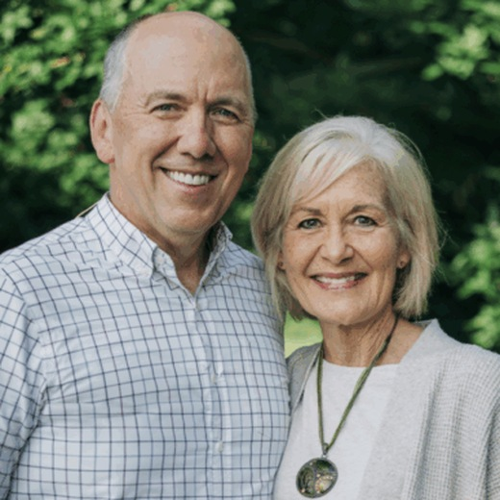 | Dr. Jonathan Schaeffer  President, The Christian and Missionary Alliance  · Tuesday, October 6 — Dial Up Your Relational IQ, with Mary, Session 2, 1:00 p.m.  · Tuesday, October 6 — Evening Service, 6:30 p.m., with Ministry Award Recognitions  · Wednesday, October 7 — Evening Service, 6:00 p.m., with Simpson University students and area youth groups  · Thursday, October 8 — DEXCOM lunch and district debrief, 12:30 p.m.  ABOUT  Dr. Jonathan Schaeffer was elected in 2025 as the 13th president of The Alliance. He is grateful to be part of this family of churches strategically reaching out locally and globally. For the previous 25+ years, Jonathan served as lead pastor at Grace Church in Cleveland, Ohio.  He enjoys spending time with his wife, Mary, and visiting a beach or national park with their five adult children, three children-in-law, and four grandchildren. The aim of Jonathan's life is simply this: “Growing in love for the Lord Jesus and for people who matter so much to Him . . . here and around the world.”

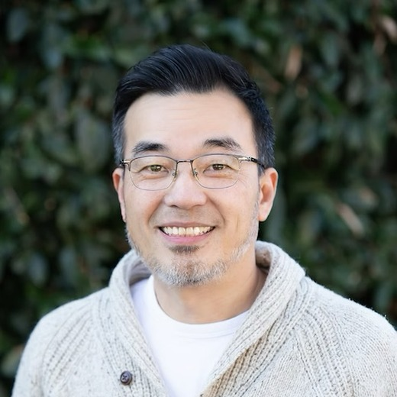 | Dr. Ted Kang  Executive Vice President, The Christian and Missionary Alliance · Board of Directors Representative  · Wednesday, October 7 — Worship Service message, 9:00 a.m.  · Wednesday, October 7 — Report of the President and Board of Directors, Business Session I, 10:10 a.m.  ABOUT  Dr. Ted Kang serves as Executive Vice President of The Christian and Missionary Alliance and as Lead Pastor of San Jose Christian Alliance Church, where he and Sandy have served since 2002 — first as missionary interns, and as lead pastor since 2014. Born and raised in South Korea, he surrendered his life to Christ at fourteen at an all-night prayer meeting his grandmother took him to. After immigrating to Canada at seventeen he came through a season of spiritual wilderness to a second life-changing encounter with God at a Youth With A Mission retreat during his final year of college.  He served with YWAM in Toronto. He has served on the C&MA Board of Directors and the Central Pacific District Executive Committee, and holds a BSc from McGill University, an MDiv from Gordon-Conwell Theological Seminary, and a DMin from Alliance Theological Seminary. He and Sandy have four daughters.

