ARISE · 2026 CENTRAL PACIFIC DISTRICT CONFERENCE
Seminar Tracks
Tuesday, October 6, 2026 · Chico Neighborhood Church
Six tracks, three sessions, one day. Cross tracks freely — almost every session stands alone. The exception is Track 1, consecutive ordination training taken as a whole. Every seminar is aimed at the same thing: E27K, reaching 27,000 people across the Central Pacific District. No sign-up; just walk in.
At a Glance
TRACK · ROOM | SESSION 1  10:45 a.m. – 12:00 p.m. | SESSION 2  1:00 – 2:15 p.m. | SESSION 3  2:30 – 3:45 p.m.
1. Ordination: The Church and Her Mission  Conference Room, Office | Part 1  Bruce Guckelberg | Part 2  Bruce Guckelberg | Part 3  Bruce Guckelberg
2. Pastoral Leadership & Relational Health  Fellowship Hall | Assessing and Mobilizing Evangelistic Health  Shanon Lee & Rick Mann | Dial Up Your Relational IQ  Jonathan & Mary Schaeffer | Revitalization for Living on Mission in Your Community  Shanon Lee & Rick Mann
3. Multiplying the Next Gen for the Harvest  Youth Center | Awaken the Next Gen  Doug McNett | Equip the Next Gen  Doug McNett | Send the Next Gen  Doug McNett
4. AI & Digital Marketing  Auditorium | ChatGPT & AI: The Basics  Bill Giovannetti  The Transformation of Communication  Ed Black | AI for Biblical Study & Intermediate Uses  Bill Giovannetti  Google, Search Engines & Your Website  Ed Black | Advanced AI  Bill Giovannetti  Display Ads, Targeted Email & Creative Development  Ed Black
5. Missions & Soul Care  Dome Chapel | Missions Conversation — Stories & Opportunities: Here, There & Everywhere  Sandy Kang | Hearing and Knowing the Voice of God  Rob & Stacy Douglas | Markers of the Soul  Rob & Stacy Douglas
6. Marketplace Ministry  Fireside Room | God Wants You on the Team and in the Game  Tommy Lee | Serving Bi-vocationally or Co-vocationally  Tommy Lee | Integrating Your Work and Witness  Tommy Lee

Note. Wordly covers plenary and business sessions only. Bring your own headphones. There will be a QR code to help you connect to Wordly in the district conference packet and on the screen prior to large session worship and business sessions.

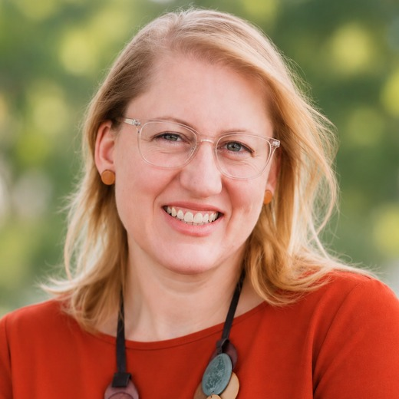 | Women in Ministry Roundtable  Jessie Wolske & Amy Bailey  Tuesday lunch, 12:00–1:00  Join other women in ministry over lunch for a time of connection. We hope to share experiences, encourage one another, and explore the unique opportunities and challenges of serving in ministry leadership. Join Jessie Wolske and Amy Bailey at lunch on Tuesday.
The Seminars

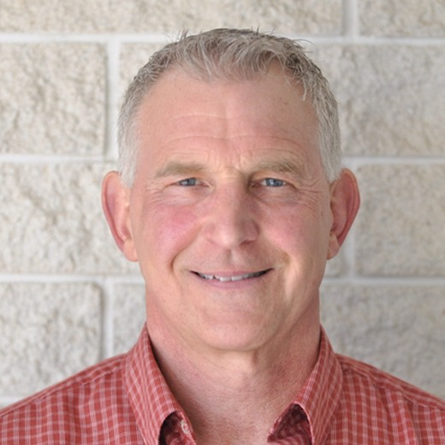 | Ordination: The Church and Her Mission  Bruce Guckelberg  All three sessions — consecutive training, attend all three · Conference Room, Office  A deep dive into the nature of the church — its relationship to Christ, its government, leadership, and essential ministries — followed by a detailed look at the mission of the church. The seminar ties directly into the E27K vision to reach souls with the gospel, and emerging leaders can fulfill two position papers through it. It runs consecutively across all three sessions, so candidates should plan to be in Room 1 for the whole day.  ABOUT THE PRESENTER  Bruce Guckelberg has been in pastoral ministry for 44 years. He earned his PhD in theology from Trinity Theological Seminary, has authored seven books, and has done extensive missionary work.  In December 2025 he assumed the position of LO&CC and Difficult Issues Coordinator for the Central Pacific District. He lives in Roseville, California with his wife Carol and their dog MayC.

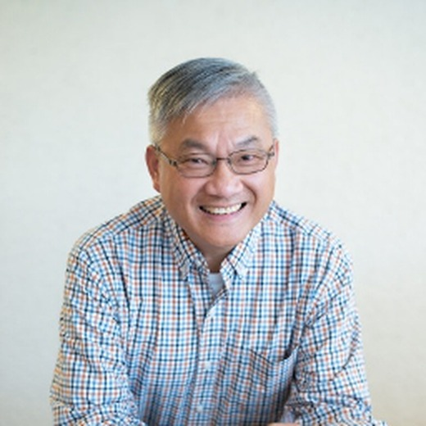  Shanon Lee  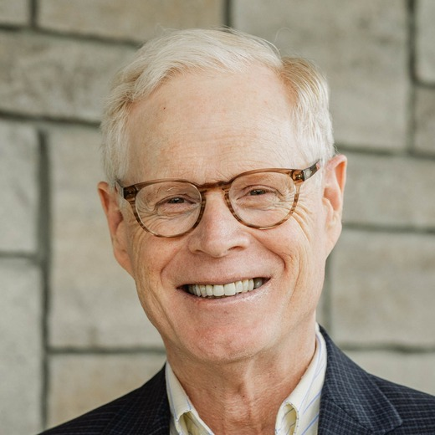  Rick Mann | Assessing and Mobilizing Evangelistic Health  Shanon Lee & Rick Mann  Session 1 only · Fellowship Hall  Assessing a church's evangelistic health helps leaders determine whether the church is effectively fulfilling the Great Commission by reaching lost people, making disciples, and multiplying kingdom impact. This seminar explores key indicators of evangelistic health, practical tools for assessment, common obstacles to outreach, and proven strategies for mobilizing a congregation toward evangelism, disciple-making, and community engagement. E27K is the sum of what individual congregations do, and this is where that accounting starts.  ABOUT THE PRESENTERS  Shanon Lee  Shanon was born and raised in Hong Kong and came to the United States for his college education. After a 19-year career in accounting and finance as a CPA and controller, he transitioned into full-time ministry, serving as a local church pastor for more than 11 years.  He joined the Central Pacific District team in 2020 as an assistant to the District Superintendent. Shanon holds a Master of Divinity and a Doctor of Ministry degree, and he and his wife, Jade, have two adult children.  Rick Mann  Rick Mann serves as the part-time Director of Leadership Development for the Central Pacific District of The Christian and Missionary Alliance. His full-time role is Professor of Leadership and Strategy at Trevecca Nazarene University in Nashville. Rick has previously served in the C&MA as a pastor, church planter, international worker, and college president. He holds an MDiv from Ambrose University in Canada, an MBA from the University of Minnesota, and a PhD from The Ohio State University.

Shanon Lee  Rick Mann | Revitalization for Living on Mission in Your Community  Shanon Lee & Rick Mann  Session 3 only · Fellowship Hall  God is calling all of us, both clergy and laity, to be engaged in his harvest work. This session will provide practical ways that congregations can live on mission in their communities in ways that will advance the Gospel and see people come to Christ. That is E27K in practice — 27,000 people reached by congregations living on mission where they already are.  ABOUT THE PRESENTERS  Shanon Lee  Shanon was born and raised in Hong Kong and came to the United States for his college education. After a 19-year career in accounting and finance as a CPA and controller, he transitioned into full-time ministry, serving as a local church pastor for more than 11 years. He joined the Central Pacific District team in 2020 as an assistant to the District Superintendent, holds a Master of Divinity and a Doctor of Ministry degree, and he and his wife, Jade, have two adult children.  Rick Mann  Rick Mann serves as the part-time Director of Leadership Development for the Central Pacific District of The Christian and Missionary Alliance. His full-time role is Professor of Leadership and Strategy at Trevecca Nazarene University in Nashville. Rick has previously served in the C&MA as a pastor, church planter, international worker, and college president. He holds an MDiv from Ambrose University in Canada, an MBA from the University of Minnesota, and a PhD from The Ohio State University.

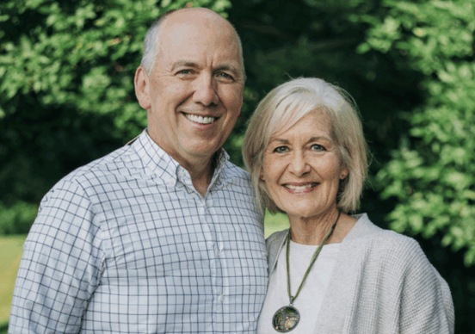 | Dial Up Your Relational IQ  Jonathan & Mary Schaeffer  Session 2 only · Fellowship Hall  Few things suck the air out of mission momentum as quickly as unhealthy team relationships. From their years of leading a staff of 50+ team members and navigating a marriage in the limelight, Jonathan and Mary share lessons learned through success and failure. You will appreciate their transparency as they wrestle with what it means — in practical terms — to look more like Jesus in the way we relate to each other. E27K will be carried by teams healthy enough to keep going.  ABOUT THE PRESENTERS  Jonathan and Mary Schaeffer are passionate about helping others grow in their relationship with Jesus Christ. Jonathan serves as the President of The Alliance and previously pastored Grace Church in Cleveland, Ohio, for 27 years — the same church where he encountered Christ as a child.  Mary's journey with Christ began in college when she came to understand the depth of Jesus' love for her, launching a lifelong journey of joy, freedom, and spiritual growth. She loves encouraging others through God's Word and pointing people to the hope found in Him. Married for 38 years, Jonathan and Mary have five children and four grandchildren, and enjoy serving together as they encourage and equip others to know Jesus and make Him known.

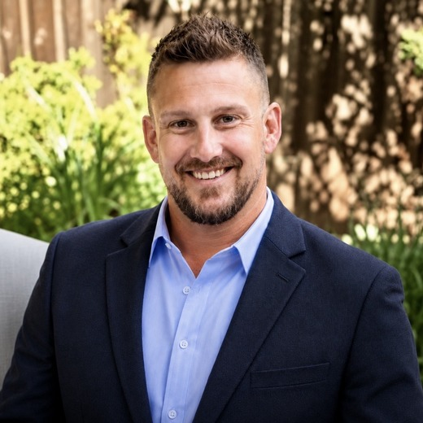 | Multiplying the Next Gen for the Harvest  Doug McNett  Awaken · Equip · Send the Next Gen · Youth Center  E27K will not be reached by paid staff. Twenty-seven thousand people across this district means a generation of young leaders who see themselves as sent — and this three-session pathway moves students and young adults from watching ministry happen to carrying it and then multiplying it beyond your church. See the mission, own the mission, multiply the mission. Each session stands on its own; the three together form one arc.  ABOUT THE PRESENTER  Doug McNett is an ordained pastor within the CPD family who has served in ministry for more than twenty years. He currently serves as Pastor of Adults, Students, and Missions at Foothills Church in Cameron Park, California. Doug studied at Moody Bible Institute and Multnomah Biblical Seminary and has taught in a variety of ministry settings while leading mission teams both locally and globally. He has a particular love for teaching Scripture and theology, especially in the context of the local church. He is passionate about equipping and releasing the next generation of leaders and workers for faithful service in the local church and around the world. He and his wife, Katie, have three sons and enjoy serving the Lord together as a family.
Awaken the Next Gen  Session 1 · 10:45 a.m.  Seeing themselves as part of God's mission. How leaders build a culture where teenagers and young adults believe God can use them now — casting vision, discipling, exposing them to the need, and inviting them to participate.  Core question: How do we move young people from being spectators to ministry participants? |  | Equip the Next Gen  Session 2 · 1:00 p.m.  From participant to ministry owner, working through a tested pathway of Attend, Serve, Lead, Own, Multiply — identifying emerging leaders, giving real rather than artificial responsibility, balancing authority with accountability, and letting them fail safely.  Core question: How do we move young people from helping with ministry to carrying responsibility for ministry? | Send the Next Gen  Session 3 · 2:30 p.m.  Releasing Next Gen leaders into the harvest. What happens once someone takes ownership — pathways into ministry, missions, leadership, internships, and mission projects, and how a sent generation multiplies the district's reach toward E27K.  Core question: How do we move young leaders from ownership within our ministry to multiplication beyond it?

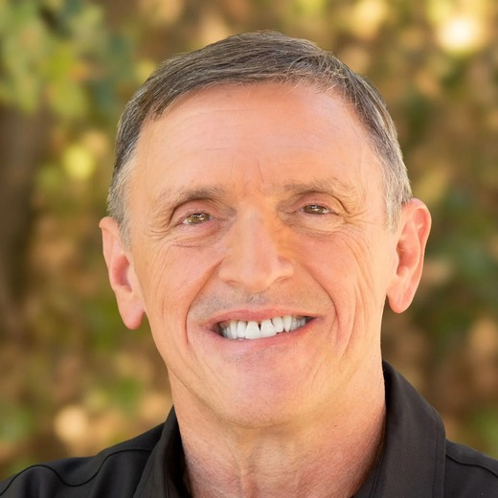  Bill Giovannetti  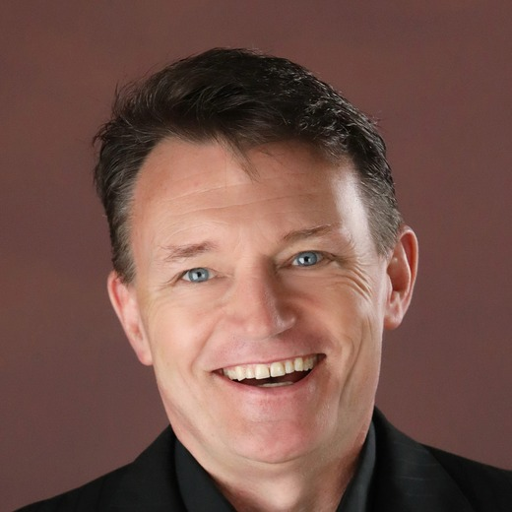  Ed Black | AI & Digital Marketing for Church & Ministry  Bill Giovannetti & Ed Black  Three sessions, two presenters in each · Auditorium  Most of the people E27K counts will find your church on a screen long before they find it on a Sunday. Every session pairs Bill Giovannetti on artificial intelligence with Ed Black on digital communication and reach, and both build across the day from foundations to advanced use. Come for one session or stay for all three. Expect named tools, and cautions about where these tools do not belong in ministry.  ABOUT THE PRESENTERS  Bill Giovannetti  Bill Giovannetti has spent more than 40 years in full-time ministry as a youth pastor, solo pastor, and church planter, and now serves as Senior Pastor of Pathway Church in Redding, leading a congregation of some 5,000. He is a published author and has taught theology and leadership in both college and seminary classrooms.  Four decades of ministry taught him that unsupported passion leads to burnout, and that a pastor drowning in administration cannot steward the gospel well. That conviction led him into technology. He founded YourCoPastor.com as a digital co-pastor for the overextended shepherd, and has built AI systems for small churches, megachurches, universities, and ministry organizations.  Ed Black  Ed Black brings nearly four decades of local church ministry together with a professional background in marketing, communications, and digital strategy. He spent 14 years as a Regional Digital Campaign Strategist for Salem Media Group, developing digital campaigns representing more than $1 million in annual billing, and now helps churches sharpen their message, strengthen their digital presence, and reach the people in their communities who are not connected to a local church.  Ed serves as Lead Pastor of The Pointe Church in Antelope and Hillcrest Church in Roseville, and as Communications Coordinator for the Central Pacific District. He holds a Bachelor of Science in Business from the University of Arizona with concentrations in marketing and human resources, a two-year Ministry Certification from the Impact School of Ministry, and certification in Applied Behavioral and Personality Analysis (DISC). He and his wife, Karen, have been married more than two decades and are the parents of their daughter, Madison Grace, whom they adopted after a nine-year journey to become parents.
Session 1  10:45 a.m. – 12:00 p.m.  ChatGPT & AI: The Basics  Bill Giovannetti  A practical introduction to ChatGPT and AI — what these tools can do, and simple ways to begin using them well.  The Transformation of Communication  Ed Black  Communication has changed dramatically, and the way we connect with people has to change with it. What today's communication landscape means for churches and ministry leaders. |  | Session 2  1:00 – 2:15 p.m.  AI for Biblical Study & Intermediate Uses of AI  Bill Giovannetti  Beyond the basics: how AI can assist with biblical study, research, preparation, and everyday ministry tasks.  Google, Search Engines & Your Website  Ed Black  Can people actually find your church online? Practical ways to strengthen your website and improve how your church shows up in Google and other searches. | Session 3  2:30 – 3:45 p.m.  Advanced AI  Bill Giovannetti  Advanced tools, workflows, and strategies that save time, expand what a small staff can do, and strengthen ministry effectiveness.  Display Ads, Targeted Email & Creative Development  Ed Black  No graphic artist needed. Affordable ways to promote your church, reach your community, and create compelling digital content with the team you already have.

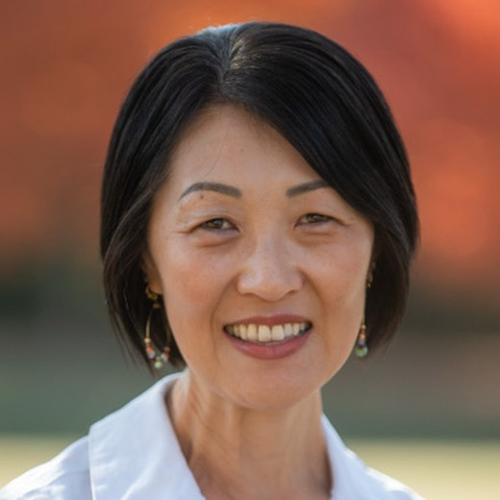 | Missions Conversation — Stories & Opportunities: Here, There & Everywhere  Sandy Kang  Session 1 only · Dome Chapel  Stories of calling, sending, and serving, told by the people who lived them — how workers were called, how churches sent them, and what those sending churches did that mattered most once someone was on the field. Sandy Kang brings the district's missions work down to what a single congregation can actually start doing this year. Churches that learn to send are the churches that learn to reach, and E27K will be carried by congregations that do both.  ABOUT THE PRESENTER  Sandy and her husband, Ted, have been pastoring at San Jose Christian Alliance Church since 2002. She is the founding director of Nexus Mentoring, where she equips marketplace leaders to mentor young adults towards Jesus and living with purpose. She previously served as the founding director of Gateway Preschool Academy and as staff director at Healing Grove Health Center.  Sandy is ordained with the Christian and Missionary Alliance and holds degrees from UC Berkeley (BA, Social Welfare), Gordon-Conwell Theological Seminary (MA, Religious Studies), and Trevecca Nazarene University (EdD). She is a proud mother of four daughters.  International Worker guests still to be named — a line and a photo needed for each.

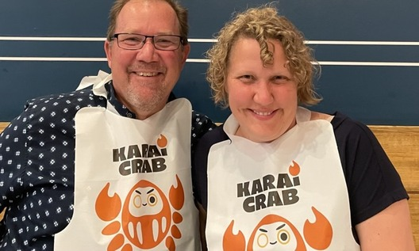 | Hearing and Knowing the Voice of God  Rob & Stacy Douglas  Session 2 only · Dome Chapel  As we seek to reach more and more people for Jesus Christ, it will take people who hear Christ's leading and walk in His direction and empowerment. This seminar walks through different ways God speaks and helps us consider how we may improve our discernment of the Holy Spirit's leading in our lives. E27K will be reached by people who can hear where He is sending them.  ABOUT THE PRESENTERS  Rob Douglas was born in Southeast Asia and spent 14 of his first 18 years there as the son of missionary parents. Across more than 30 years of ministry he has served the C&MA in district and denominational leadership, pastoring, and international missions, and now serves as District Superintendent of the Central Pacific District. Stacy is a pastor's kid who grew up in Michigan and Florida, worked as a nurse before serving overseas in Thailand and Iraq, and served as Director of International Placement for the C&MA; she now works as a Registered Nurse and serves the district alongside Rob. They live in Citrus Heights and have three adult children, two daughters-in-law, and a first grandbaby this past year.

Markers of the Soul
Rob & Stacy Douglas
Session 3 only · Dome Chapel
Some of us have allowed boulders to clog the flow of God's Spirit in our lives. This seminar helps us consider what those boulders are and what markers we should have seen along the way, then looks at the gauges of the soul — how we are doing in each category and what we can do to move toward greater intimacy with Jesus. A leader running on empty will not carry E27K; this is about the condition underneath the calling.
ABOUT THE PRESENTERS
Rob Douglas was born in Southeast Asia and spent 14 of his first 18 years there as the son of missionary parents. Across more than 30 years of ministry he has served the C&MA in district and denominational leadership, pastoring, and international missions, and now serves as District Superintendent of the Central Pacific District. Stacy is a pastor's kid who grew up in Michigan and Florida, worked as a nurse before serving overseas in Thailand and Iraq, and served as Director of International Placement for the C&MA; she now works as a Registered Nurse and serves the district alongside Rob. They live in Citrus Heights and have three adult children, two daughters-in-law, and a first grandbaby this past year.
Rob especially enjoys time with family and friends, sharing stories of God's working, fishing, and flying kites. Stacy is passionate about family, lost people, wholistic health, and anything outdoors.

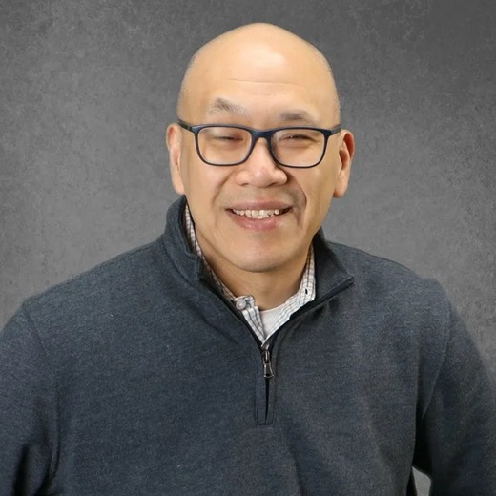 | Marketplace Ministry  Tommy Lee  Three sessions across the day · Fireside Room  Most of the 27,000 will never meet a pastor first. They will meet someone from your congregation at work, which is where your people already spend most of their week and where the mission field actually is. Across three sessions Tommy Lee moves from a theology of work, to the practical shape of bi-vocational and co-vocational ministry, to what it takes to be a genuine witness in your own workplace.  ABOUT THE PRESENTER  Tommy Lee is the founder and president of Resource Global, an organization that teaches, mentors, and connects emerging Christian marketplace leaders so they can renew their cities and workplaces for the gospel. He oversees a team of city directors based in Chicago, Austin, Jakarta, Medan, Kuala Lumpur, Singapore, Nairobi, Pretoria and Johannesburg, and Hong Kong, and has partnered on initiatives with Redeemer City to City, the Lausanne Congress, InterVarsity Christian Fellowship, the Urbana Missions Conference, and the Willow Creek Leadership Summit, among others.  He also serves as Executive Director of The Grow Center for Church and Mission at Northern Seminary, Managing Director of TogetherLA, and founder of CreatePossible LLC. Before moving into nonprofit work he spent time in telecommunications, two years pastoring at Lakeview Church in Illinois, and fifteen years with high school and college students at Chinese Christian Union Church in Chicago. He holds a bachelor's degree from Washington University and a master's degree from Moody Theological Seminary, and lives in Chicago with his wife Charlene and their daughters Samantha and Karra.
God Wants You on the Team and in the Game  Session 1 · 10:45 a.m.  A theology of work and engagement — why the work your people already do is part of God's mission rather than a distraction from it. |  | Serving Bi-vocationally or Co-vocationally  Session 2 · 1:00 p.m.  Integrating marketplace and ministry roles: for pastors carrying outside work, and for marketplace leaders carrying real ministry responsibility. | Integrating Your Work and Witness  Session 3 · 2:30 p.m.  How to be more effective in your workplace and a greater witness within it, without treating the two as separate jobs.

